Private 306326 George William Dix DEARLOVE
‘X’ Company 2nd/7th Bttn Royal Warwickshire Regiment
Birmingham City Police ‘D’ Division
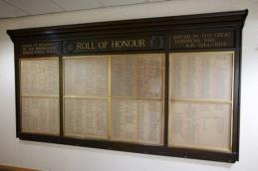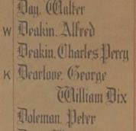
Died of wounds France 25th October 1918 aged 24

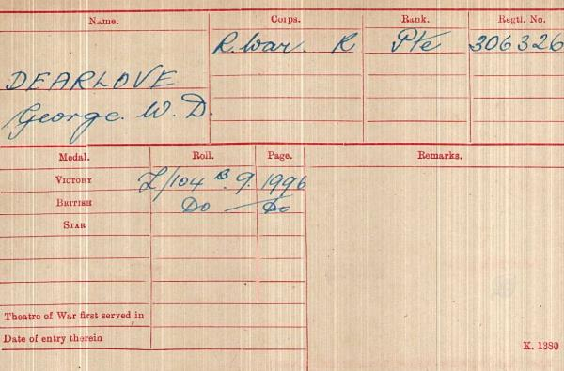
British Army WW1 Medal Rolls Index cards 1914-1920

Police Service history

George joined Birmingham City Police on 1st December 1913 aged 19 leaving his position as railway porter.

He served on the ‘D’ Division. His warrant number was 8417 and he left the force 15th November 1915 to enlist, in Aston, Birmingham.

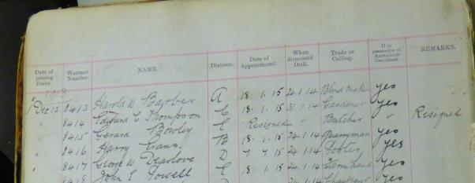

1918 and 1919 absent Voters List

Shows George residing at Victoria Road Police Station
With fellow officers on the Roll of Honour

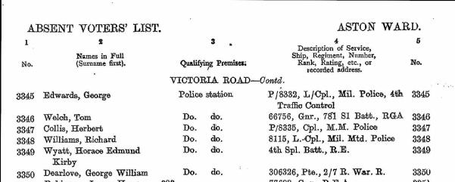

Birmingham City Police records dated 12th November 1915 lists police constables who have been granted permission to join His Majesty’s Forces. They were to parade in uniform at Newton Street Police Station at 10am on Monday next, the 15th inst and to march to Curzon Hall.

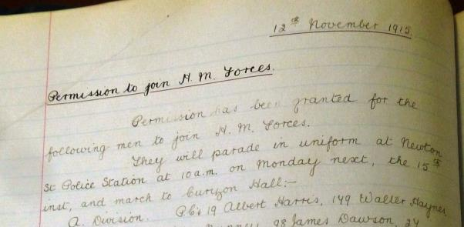

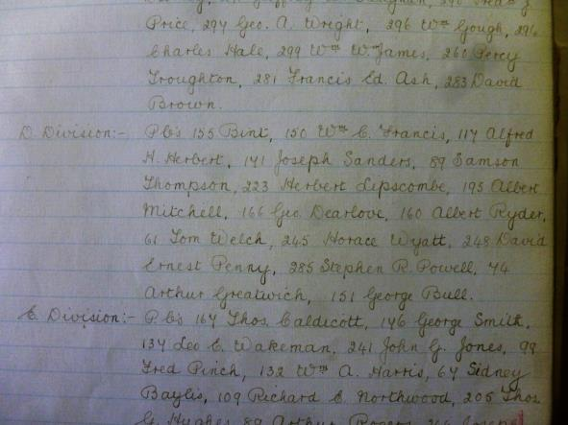

Birmingham City Police records dated 20th November 1916 confirms PC George Dearlove of the ‘D’ Division has been wounded

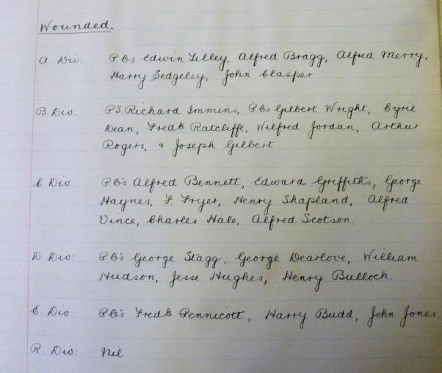

A Service was held at The Parish Church, Birmingham
Sunday 5th December 1920 3.30pm
Remembering those police constables Killed in action, those who died on active service and those who died from illness due to war service

George W D Dearlove is listed as serving on the ‘D’ Division

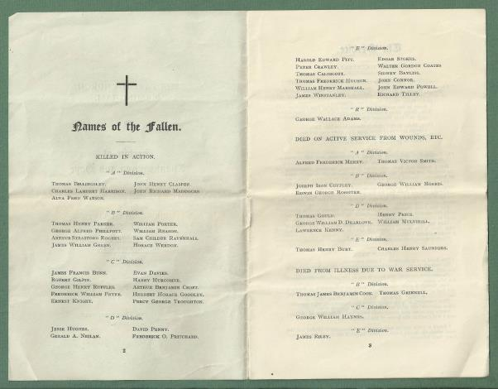

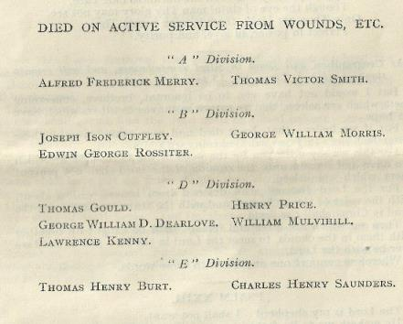

War service history

George was wounded in action between Montrecourt and Vendegies, East of Cambrai attacking the Hindenburg Line and was removed to either the 38th, 45th or 59th Casualty Clearing Station at Awoingt, just south east of Cambrai were he succumbed to his injuries at 24 years of age.

On Wednesday 23th October 1918 George's battalion left camp at Rieux, were they had been in training and moved to positions near Montrecourt. At 4 am the following morning the battalion advanced towards the village of Sommaing, the War Diary recording the attack thus, "10th Brigade '4th Div.' on our left, 2/6th Royal Warwicks on our right. Attack was preceded by artillery barrage. Z Coy on left got across River Ecaillon quite well but met with M.G. fire and also a good deal of wire defences, but pushed forward and reached a further defence system in Q7b which was very strong with front and support trenches and communication trenches. X Coy on right came up against much resistance, river being wired heavily on both banks and on the enemy side were a considerable number of M.G. posts.

They managed to cross river to the strength of a platoon but were counter attacked and withdrew to a line in Q13b on the rear slope of ridge with two forward posts at Q13b92.W Coy advances in support of Z Coy on left and established three posts in front of village but owing to a misunderstanding Z Coy had withdrawn across river and information of these three posts did not come through in time to be of any use. Y Coy had advanced in support of X Coy but without any success. 1000-Z, W and Y now reorganised and pushed forward from P18b94 towards the village, position remained like this till 1645. 1645-at this time 2/8 Worcester’s passed through us and reached Mur Copse Q7 which had been cleared earlier by the 4th Div. From here they advanced from NW to SE direction, the 184 Bde at the same time pushing up from SE of Vendegies.

All Coys now pushed forward in support of Worcester’s." The following day the War Diary records, "Sommiang now clear of enemy and Brigade objective reached on a line running from NE corner of Mur Copse to Q8a92. Trench state 22 officers, 503 other ranks." Casualties amounted to 1 officer killed and 4 officers wounded with 28 other ranks killed or missing and 170 wounded.

War Events of George William Dix DEARLOVE

In 1915 aged 21 he is shown as a resident of Aston and being in the 7th Battalion of the Royal Warwickshire Regiment.

1 Nov 1915 to 3.12.1915 Attested and embodied
15.11.1915 He had a medical at Aston Barracks where he gave his place of birth as Banbury, Oxford and his occupation as a Policeman
04.12.1915 to 5.2.1916 L/Cpl Royal Warwickshire
6.2.1916 reverts to Private on joining 1st 8th Royal Warwickshire regiment and travelled to France
23.02.1916 He joined the unit in the field, joined base depot in France.
26.03.1916 He sustained a gun-shot injury to his right arm and was taken to 29 Casualty Clearing Station
27.03.1916 He sustained a gunshot wound to his right Arm - To 3 A.T.
29.03.1916 Travelled to Rouen
08.04.1916 to 14.10.1916 He was in Princess Christian Hospital Weymouth with a gun-shot wound to his right arm.
28.04.1917 Appointed acting L/Corp
26.05.1917 He was fully appointed L/Corp and Paid
29.03.1918 He reverted to Private on embarkation
25.10.1918 45 Casualty Clearing East of Cambrai station Died of wounds.

On George’s death his effects were sent to and signed for by his next of kin Mrs Ellen Dearlove, at Bletchington in Oxford – They were a Purse, photographs, a fountain pen, letters, a wallet, two knives, 2 religious books, a pouch, a badge, a pipe, and cards.

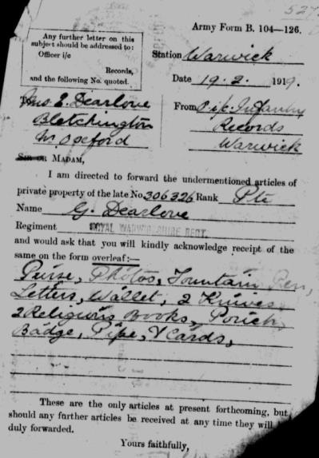

George William Dix Dearlove

Appears in a
Register of Lad Clerks No.7 1908-1911
Great Western Railway Company

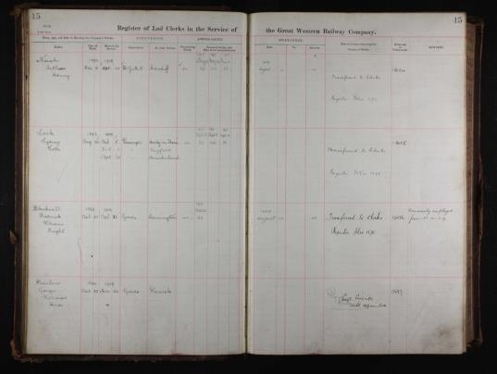

Dearlove George William Dix

April 22nd 1894 - March 22nd 1907

Goods at Warwick

Left Service by request not appointed

George was admitted to and spent 190 days in a military hospital, ‘Princess Christian Hospital’, Weymouth, Dorset between 8th April and 14th October 1916. He was treated for gunshot wounds to his right arm that occurred in France, March 1916.

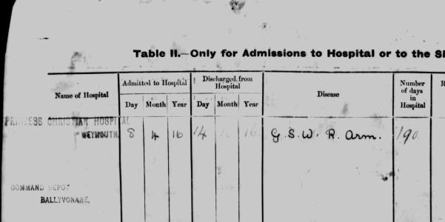

An Army Form notifies to George’s wife that articles are to be sent to her current address.
The word ‘plaque’ is distinguishable; the word with the date stamp may be ‘scroll’.

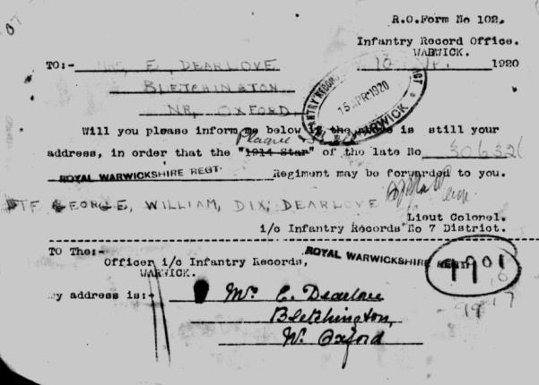

Army Form B.178 - Medical History (Regular Army only)
George William Dix Dearlove was examined on 15th November 1915 at Aston Barracks. George stated he was born in Banbury, Oxford. At the time of his examination he was 21 years and 6 days of age. He gave his occupation as a Policeman

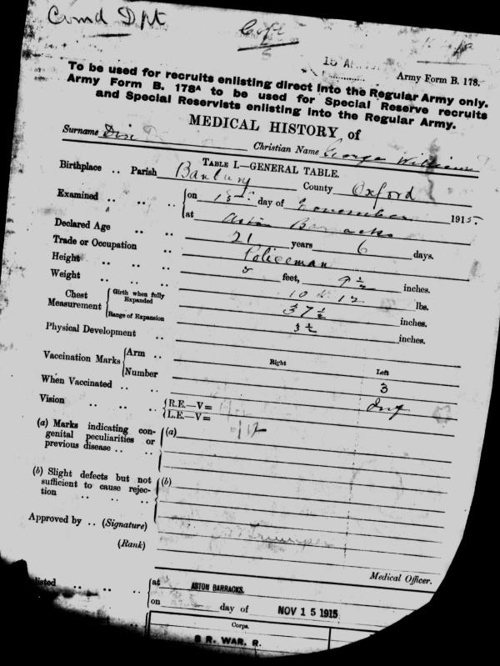

Army form signed by George William Dix DEARLOVE

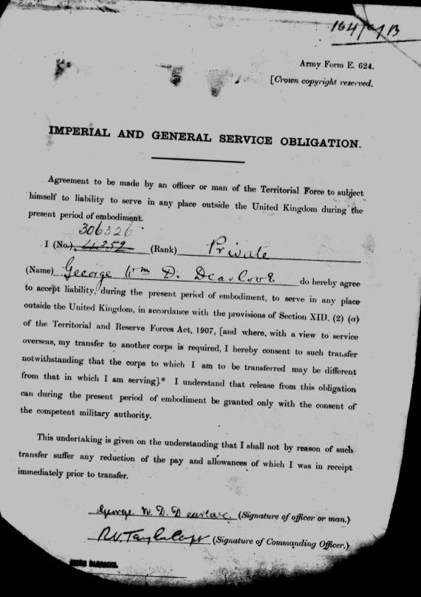

Army Form E.624 - Consent of George as a member of Territorial Force to serve overseas.

It confirms that George Died of Wounds received in action at Number 45 Casualty Clearing Station in France

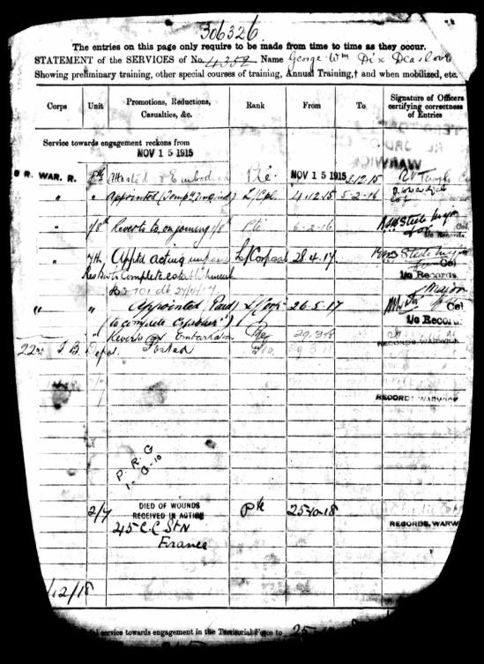

George’s service record from enlistment 15th November 1915 to his death 25th October 1918

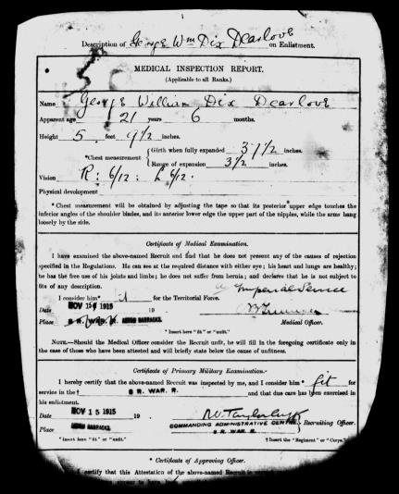

George’s Medical Inspection Report on enlistment 15th November 1915

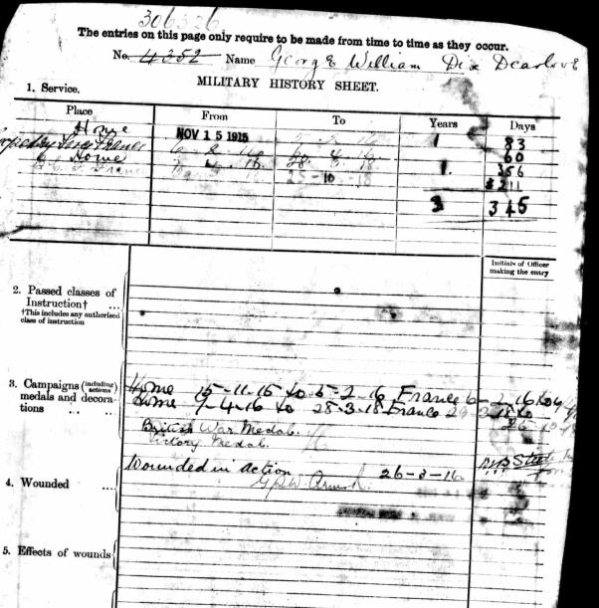

George’s Army Form B.103 – Casualty Form – Active Service

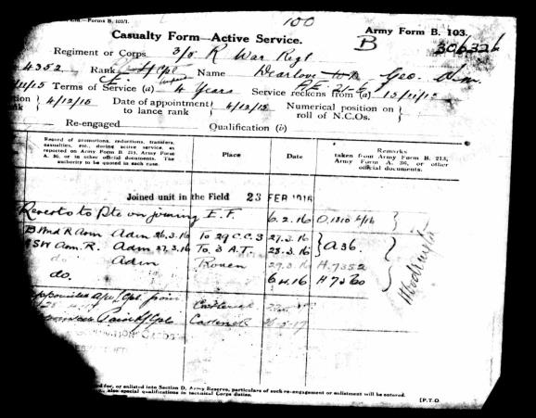

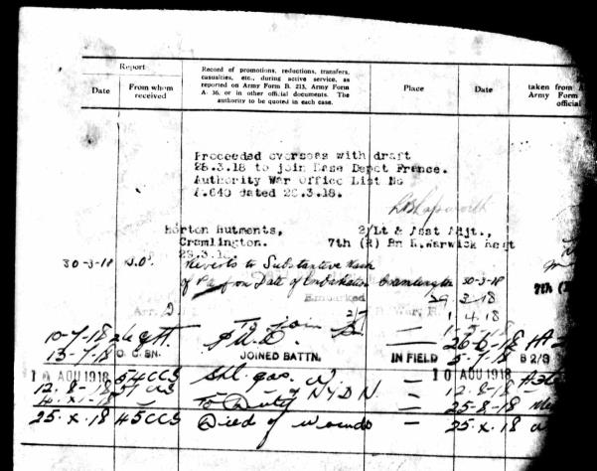

Buried Grave 1 G 10
Awoingt British Cemetery
France

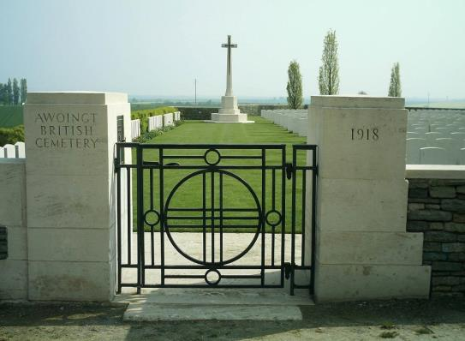

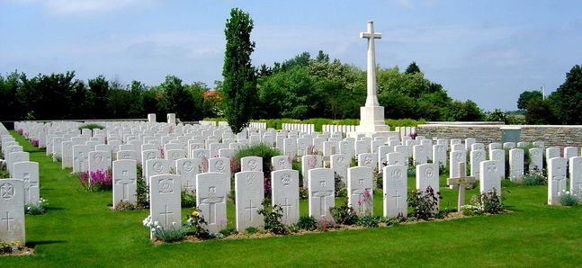
Inmemories.com

George is named on the headstone of his mother’s grave Ellen Dearlove at Bletchington St Giles Churchyard and Extension, Oxfordshire.

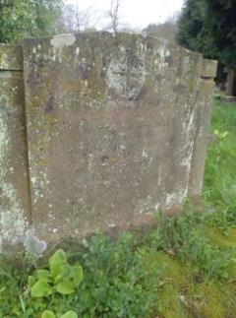

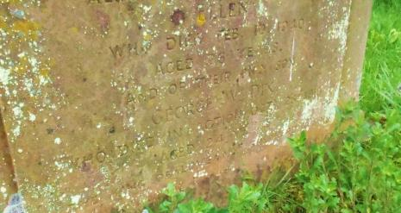

Antecedents of George William Dix DEARLOVE

- Born 22nd April 1894 in Grimsbury, Northamptonshire son of George and Ellen Dearlove (nee Dix).

- George had two younger sisters, Ellen Mary A born in 1899 and Emily, born 1902. In the 1901 census the family were living at 8 Arden Terrace, Birmingham Road, Stratford on Avon. George's father was a railway signal man. They were still living there in the 1911 census when George was calling himself by his second name, William. He said that he was a shop assistant bookseller

- 1918 Voters shows him residing at Victoria Road Police Station serving in 2/7th Royal Warwickshire Regiment

